Opposites
&
Cheating

Picasso worked by night, Matisse by day.

From Matisse and Picasso: The story of their Rivalry and Friendship, by Jack Flam

The relationship between creativity and research is never easy. In 2001, Ian McEwan’s novel Atonement was criticised for drawing on memoirs by Second World War nurses; such work, it was implied, was somehow cheating.

Josephine Balmer, in a review of Andrew Motion’s The Custom House.

“To read Eliot is, for me, to feel the presence of the abyss; to read Rilke is to feel the mattress under the window.”

Louise Gluck, Proofs and Theories

In other circumstances, cheating might be a viable strategy, at least for a small subset of the population. This is clearly an appropriate framework for interpreting acoustic communication - the authors devote a section to “bluffing” in frogs, where males lower their call frequency in response to a rival (the lower the call frequency, the larger the frog, in general). Albertus Magnus would undoubtedly be surprised quite how much - and how little - science has developed since he first took the head off a chirping cricket.

So far no sculptural portraiture exists: the Bust is a sentimental paperweight and the statue is an object of idolatry.

Andre Salmon on French Modern Art

“I am a real Minimalist, because I don’t do very much. I know some minimalists who call themselves minimalist, but they do loads of minimalism. That is cheating. I really don’t do very much.”

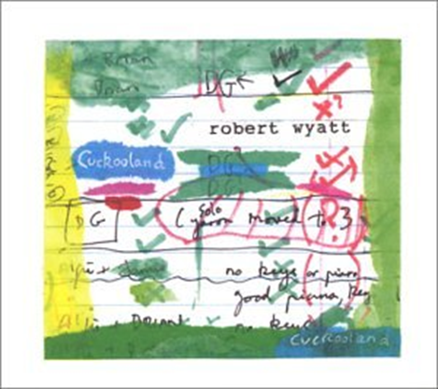

Robert Wyatt on minimalism, quoted in a review in the Times Literary Supplement, 10 December 2014

“Where variety interests Williams, choice is Eliot’s obsession.”

Louise Gluck, from Proofs and Theories

Although I had internet access in my apartment, I claimed in my emails to be writing from an internet cafe. I tried my best not to respond to most of the emails I received as I thought this would create the impression I was offline, busy accumulating experiences, whereas in fact I spent a good amount of time online, especially in the late afternoon and early evening. After responding to my emails I would attempt to read the Quixote in a bilingual edition, eat something, usually chorizo, hard cheese, olives, and white asparagus from a jar, open a bottle of wine, abandon the Quixote and read Tolstoy in English.

Ben Lerner, Leaving the Atocha Station

Whereas Einstein was gregarious and full of laughter, Gödel was solemn, solitary, and pessimistic. Einstein freely indulged his appetite for heavy German cooking; Gödel subsisted on butter, baby food and laxatives. Einstein was jolly and at home in the world; Gödel, by contrast, had a tendency towards paranoia. He believed in ghosts; he had a morbid fear of refrigerator gases; he refused to go out when certain distinguished mathematicians were in town.

Jim Holt, When Einstein Walked with Gödel

She is shown doing a jigsaw puzzle: a small woman with small, brown, brilliant eyes ... wearing a plain but pretty dress, chattering and eagerly questioning herself, as she stands before the large puzzle . . . . “How beastly they are to put so much water in these things. It’s cheating. What a bore. Ah, now - here, do you think?”

Consider their use of a single word, serious. In 1988 Susan Sontag told an interview, “Sometimes I feel that, in the end, all I am really defending is the idea of seriousness.” Seldom does Pauline Kael use the word any way but ironically, as a term of derision – not serious, but “serious.”
Craig Seligman, Sontag & Kael: Opposites Attract Me

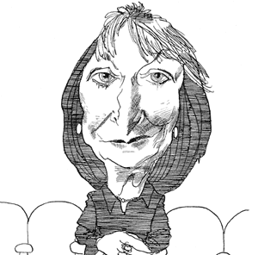

Thoughts Haunting Me in Busy Streets

Faces.
Billions of faces on the surface of the world.
Supposedly each different
from those that were and will be.
But Nature—and who can really tell—
maybe tired from constant work
repeats her former ideas
and puts on us faces
already worn.
Maybe Archimedes in jeans is passing you by,
Catherine the Great in second-hand clothes,
one of the pharaohs with a briefcase, in glasses.
A widow of a barefoot cobbler
from a still small Warsaw,
the master from the cave of Altamira
taking grandchildren to the zoo,
a shaggy Vandal on the way to a museum
to get his delight.
Billions of faces on the surface of the world.
Your face, mine, whose—
you will never find out.
Maybe Nature must cheat,
and to keep pace, and to keep up
she starts to cast for what is sunk
in the mirror of oblivion.

Wislawa Szymborska

Williams had a moral commitment to the actual, which meant the visible, whereas it was Eliot’s compulsion to question that world. ‘Unreal city’ as opposite, say, to ‘January morning.’ It is important to keep in mind the fact that Eliot was human: this accounts for the helplessness in his verse.

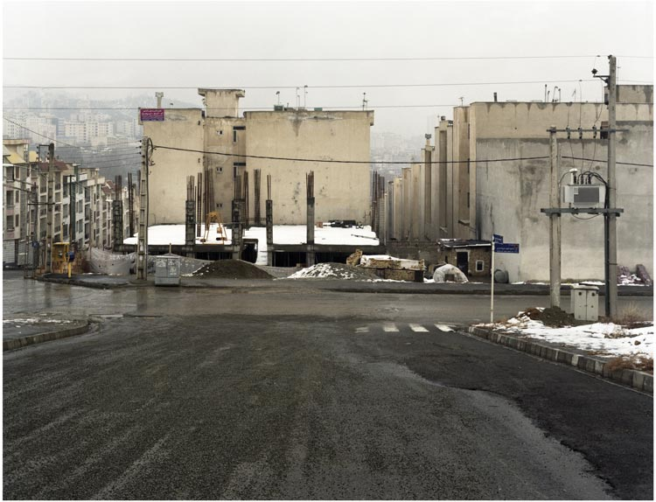

Louise Gluck, from Proofs and Theories

He is happy and amusing; he is unhappy and serious; he tries a lot of different things; he is preoccupied with the world, with experience, with flux. No wonder then that he writes so much about weather, and not just any weather: wind and sea surfaces are his metier. Now he is clear and “accessible”; now he is fuzzy and surreal. Instead of surreal, I think of this explanation he offered: “It may be that poetry makes life’s nebulous events tangible to me and restores their detail; or conversely, that poetry brings forth the intangible quality of incidents which are all too concrete and circumstantial. Or each on specific occasions, or both all the time.” If I’m cheating by building my own manifesto out of the bones of another’s, I apologize. I too want poetry to be a response to the weather: the world’s, and the author’s own. I can’t really say anything more definite for the time being . . . except that I will not be writing any “book-length projects.”

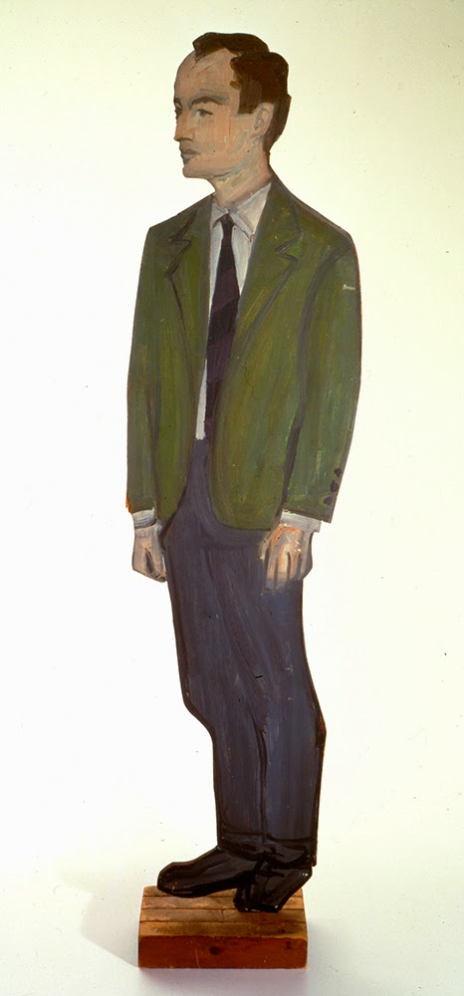

Ange Mlinki, “The Eighties, Glory Of: a manifesto”

The House With Only An Attic And A Basement

The woman in the attic did not have visitors.
The man in the basement gave parties that were popular.
The woman in the attic had mononucleosis.
The man in the basement had type 1 diabetes.
The woman in the attic listened to audiobooks which the man in the basement held in disdain.
The door to the attic swelled in some weathers; in order to shut, it had to be slammed.
“There is a way in which” was a way in which the man opened sentences, as in “There is a way in which to close a door so it doesn’t slam.”
The man in the basement wrote stories about heroin.
The woman in the attic read stories with heroines.
The man in the basement was in love with the sister of the secretive man who loved him more.
He whooped at the woman, “You killed your student?”
To himself he wept, “I killed my father.”
The man in the basement, recently divorced, was left with literally two possessions.
The woman in the attic purchased books on psychopathology.
The man in the basement moved to the West Coast;
the woman in the attic crossed the Atlantic,
whereas the house with the attic and basement saw states
of fumigation, exorcism, detoxification, and rehabitation.

Kathryn Maris

Do artists cheat? A bus ticket was the nearest we got to it in my art school days. The secret from the Euston Road was that London Transport tickets (which strangely came in all sorts of Sickertian mauves and Ginneresque greens) had neat divisions along their sides. These, at arm’s length, served to measure key proportions of the model, eyes to mouth, nipple to navel, etc. It was considered an advance on the traditional squint at a raised pencil.

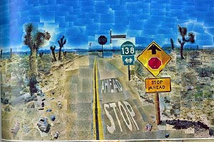

Tom Philips “Optical Magic,” TLS 2001

Matisse thought with his brush, and in a sense discovered his pictures in the act of painting them. Picasso, by contrast, always had a strong narrative gift, and his brush generally followed his preconceived idea of what the picture would look like.

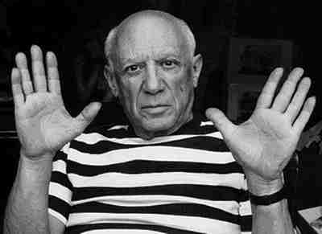

From Matisse and Picasso: The story of their Rivalry and Friendship, by Jack Flam

He sought the hand of Hippodameia, a princess whose royal father had declared that, in order to win her, a suitor had to defeat him in a chariot race. When Pelops arrived he was not even daunted by seeing the skulls of his twelve unsuccessful predecessors nailed to the palace gates. Fortunately, Hippodameia fell in love with Pelops and the two conspired to have the metal wheel pins of her father’s chariot replaced with wax, which would melt during the heat of the race and loosen the wheel. The king lost both the race and his life, and Pelops won his desired bride. That his victory was based on cheating is yet another familiar mythological topos. We see this as early as the Homeric epics - the important thing was always to win.

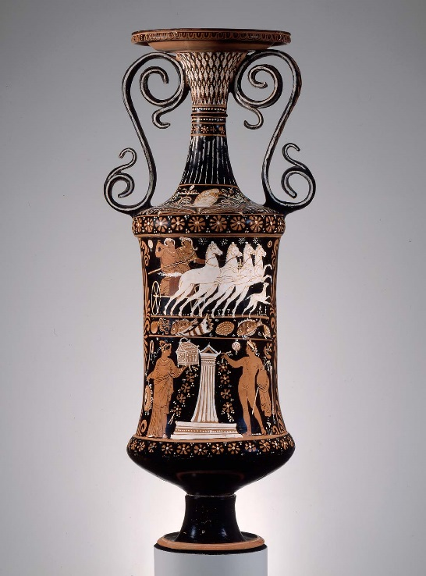

p.s. The hero’s entire life was emblematic of the most prominent motifs in Greek mythology. As a boy he suffered a kind of ritual dismemberment: he was served up to the gods in a stew and nearly eaten.

“But when you’re not speaking with skin
You must love with language.”

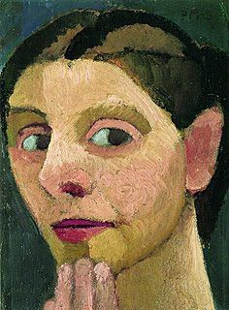

Anne Michaels “Modersohn-Becker”

